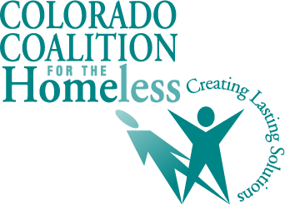

Support HB24-1099 Defendant Filing Fees in Evictions
Representatives Lindsay & Soper, Senators B. Pelton & Buckner

The Problem:

When a landlord files an eviction against a tenant, that tenant may file a document called an answer. This gives the tenant an opportunity to explain their perspective on the matter or dispute the claim of a lease violation (most commonly non-payment of rent). Most importantly, it allows the tenant to participate in the eviction proceedings rather than face a default judgment and automatically lose their home. The cost to file an answer is $80 (or $84 in the case that a tenant is making a counter claim against the landlord) which can be prohibitively expensive for some tenants. There is a waiver process for indigent tenants, but requesting the waiver can be stigmatizing and it may still discourage tenants from defending themselves in court.

The Solution:

Colorado should eliminate the fee to file an answer to an eviction. This would benefit all parties involved in eviction proceedings:

- Tenants would be spared the indignity of asking for the $80/84 to be waived, would be more likely to file an answer, and would be less likely to face a default judgment and lose their housing;
- Legal aid attorneys would be able to dedicate more time providing meaning legal assistance to tenants and waste less time completing and filing waivers;
- The Colorado Judicial Department would waste less time and money sifting through and approving waivers; and
- Landlords would be more likely to receive back rent if tenants are not spending their limited money on fees (a significant portion of eviction filings are for small dollar amounts as low as $4).

The cost of eliminating the answer filing fee would be minimal. In 2022, the Colorado Judicial Department collected just $161,102. In fact, the Department may realize savings by reduced staff time dedicated to reviewing and processing fee waivers.

For more information please contact:

Jack Regenbogen Aubrey Wilde
Colorado Poverty Law Project Colorado Coalition for the Homeless
jack@copovertylawproject.org awilde@coloradocoalition.org

Amanda Gall and Adeline Hodge Danny McCarthy
Meridian Public Affairs Mendez Barkis and Associates
amanda@meridianaffairs.com danny@mendezbarkis.com

Endorsing Organizations:

Colorado Children's Campaign
Colorado Coalition for the Homeless
Community Economic Defense Project
Colorado Cross Disability Coalition
Colorado Poverty Law Project
Denver Metro Fair Housing Center
East Colfax Community Collective
Enterprise Community Partners
Growing Home
Lutheran Advocacy Ministry Colorado
United for a New Economy

