GREEN ENCHILADAS (OFELIA’S STYLE)
½ or 1 cup of Monterey cheese or Munster cheese or Asadero cheese
1 ½ cans of Campbell’s Cream of Chicken soup (You can use other brands as well)
½ of an 8oz Philadelphia Cream Cheese brick (It could be other brands)
2 Serrano chiles
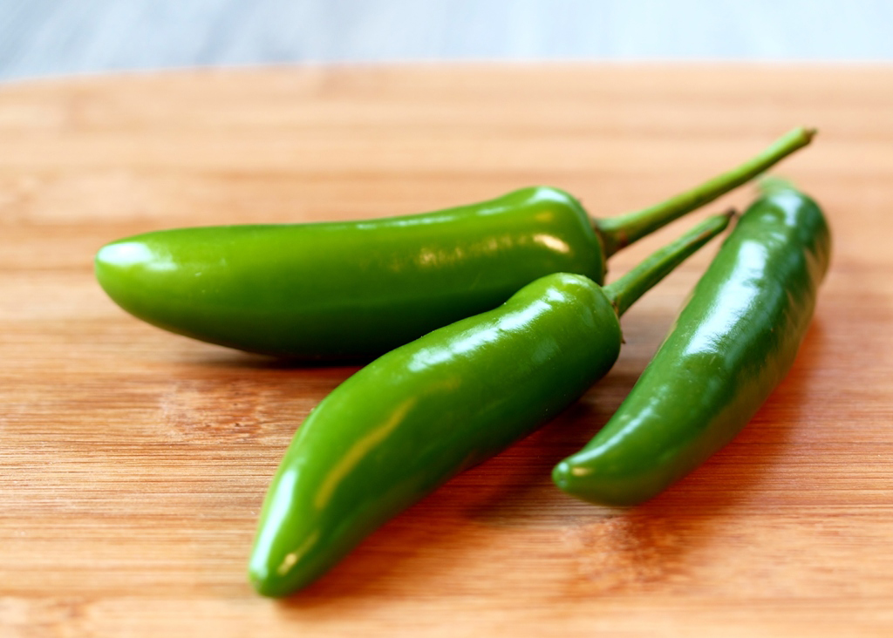

(You can use one if you do not like it too hot or can use more if you like spicy food)
1 cup of Chicken bouillon (You can use the water where you boiled the chicken)
1 spoon of oil (you can use 1 teaspoon instead if you wish)
Oil (You can use any oil to warm the tortillas on both sides)
3 chicken breasts
25 corn tortillas

Liquefy the cream cheese, 1 can of the Cream of Chicken, the two serrano chiles and one spoon of oil. (Put to boil and add I cup of the chicken bouillon and the other ½ can of the Cream of Chicken. (Boil for10 or 15 minutes)
Warm the tortillas with oil on both sides until they are soft.

Drown the tortillas in the mix one at a time, take them out and fill tortillas with chicken mix.
Roll up and place in a greased baking dish or foil pan.
Spoon remaining (You can use all of it or as little as you want) sauce over the enchiladas.
Sprinkle the cheese on top.
Put in the oven for 15 to 20 minutes until the cheese is melted at 350°

