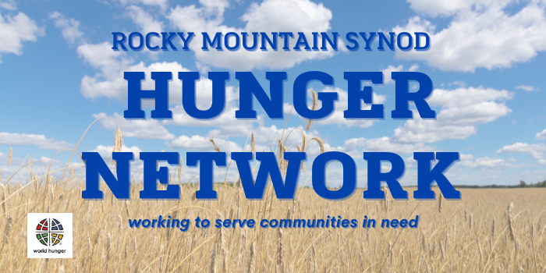

How can you meet the “Therefore Be It Resolved” sections of the Hunger Network’s resolution?
Support Local Hunger Ministries
What is happening in your community? Are food banks and feeding ministries struggling to keep up with demand? Are there holes in service to parts of the community? Are there trusted organizations that you can support? ASK THEM WHAT THEY NEED! If you believe there are holes in services, BE INTENTIONAL about what you might create! Learn before you act; walk alongside your neighbors.

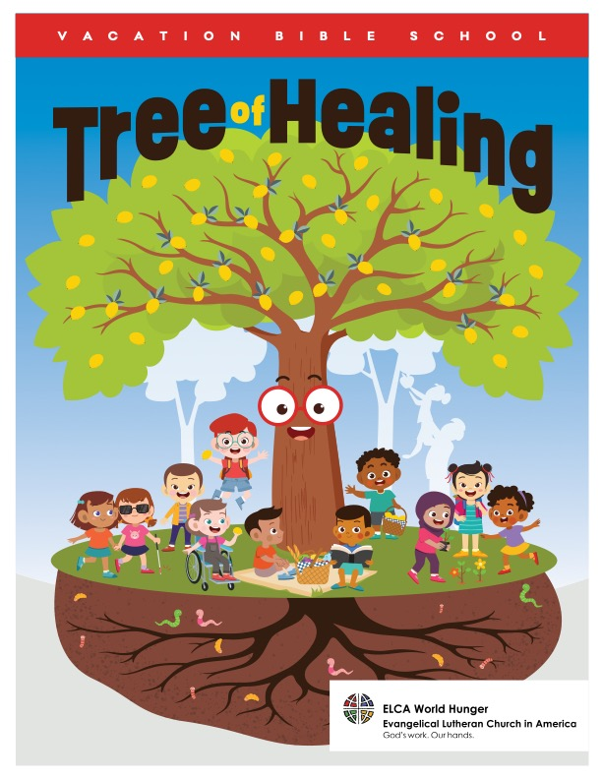
Increase Awareness of Hunger and Poverty Issues
Go to elca.org/hunger/resources and browse through all the possible resources you can use. Consider trying ELCA World Hunger’s VBS curricula (FIVE versions!), confirmation and youth ministry resources, toolkits designed to explore many topics that intersect with hunger and poverty, planning guides for beginning or evaluating feeding ministries, bulletin insert stories about the work we support together, compelling videos, ETC. Encourage adults to use devotional books for Lent and Advent and sign up for Hunger Blog updates. Encourage members to sign up for the “Thirsting for Water” climate impact event on September 17!

Increase Opportunities for Financial Support
This can be as simple as putting ELCA World Hunger envelopes in your pews. Highlight a story of this ministry through bulletin inserts or showing a video and encourage members to make a financial gift. Use the 40 Days of Giving resources during Lent and take an intentional offering on or around Easter. Plan a FUNdraiser with youth. Encourage members to sign up for Monthly Partners (elca.org/monthlypartners) and consider Good Gifts (elca.org/goodgifts). Tell the story and invite a response!

